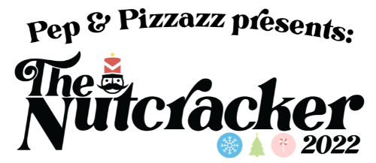
Nutcracker 2022 HERE WE COME!!!! With auditions already done and class roles announced… we are ready to kick it up a notch for Nutcracker here at Pep! Nutcracker is something that we just LOVE around here and a huge reason why we love it so much is because our kiddos love it so much! We will perform our production on December 2nd and December 4th Somerset High School! Here are the important details you will need to know:

Participation & Nutcracker Fee

Nutcracker is open to any of our dancers in our Mini, Junior, Senior, and Adult Dance Classes. It is not required that all students participate in Nutcracker BUT it is one of the best things we do here at Pep & Pizzazz and we really encourage all of our students to get involved! Nutcracker not only gives our students a performance opportunity where they can take what they are learning in their classes and be celebrated on stage, but it also gives them something to be a part of! You will see the PepFam over the next few months come together to create an amazing show and that is an experience we want all of our students to get to be a part of! If your child WILL NOT be participating in the 2022 Nutcracker with their dance class, you will need to complete this opt out form through the google form link.

https://forms.gle/31ExYH8BjJmjSHXaA

We need to know by September 23rd if your child is opting out as we are already getting to work on choreography in our classes.

Our Nutcracker Fee of $65 will be posted to your Jackrabbit account and your card will be charged for $65 on September 26th. This fee will cover all costume rentals and purchases, costume alterations, backdrops, digital action shot photos from the show, and a variety of other Nutcracker expenses. Our Nutcracker is a BIG PRODUCTION! If you would rather pay by cash or check you may do so by sending in an envelope with your child’s name on it and marking it as “Nutcracker Fee”. This must be received by September 23rd to avoid it being charged to your card.

*If you complete the OPT OUT google form, your card will not be charged – this fee is only for those who will be participating in the Nutcracker Production. Your child will still be involved in each and every class! They will be engaged regardless of their Nutcracker participation choice.

Class Dances & Individual Roles
We have already revealed our class and individual roles and they can be found here by clicking this link!

https://youtu.be/au95-I5rLXo

Class Attendance
Class Attendance is important all of the time if we want to see our students learning and growing in their skills. It is equally as important when we are putting together a show! Set your child up for success and be sure to make their weekly dance classes a priority!

Important Dates

November 28th-30th: Tech Week Rehearsals at Somerset High School

December 1st: Dress Rehearsal at Somerset High School

December 2nd & 4th: These are our show dates! We will do a Friday evening show at 6:30pm and a Sunday afternoon show at 3:00pm.

December 3 – Annual Chamber of Commerce Christmas Parade We will have a float in the Christmas Parade this year! Mark this date on your calendar and stay tuned for more details!

Fundraising
We need your help! Our Nutcracker Production expenses come close to $10,000. This is what is takes to give our students the high-quality Nutcracker experience they are used to! Nutcracker Sponsorships make it possible for our production to bring the Nutcracker to life and to make our students feel like the stars they are! Please take a look at the Nutcracker Sponsor packet and get those sponsors!

